youssef ezzat

[Email address]

Abstract

15/8/2021

DEcumentation

Final Project

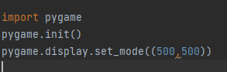This collection of blocks is for the initialization of the pygame library to make games on python.

This is for setting the window size which the first number for the height and the second number for the width.

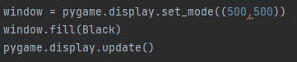 This block is for filling the screen with a color which we filled the screen with black color, the last block is for updating changes we made to the game like updating the colors and the players.

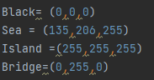

This part is for initial the color coordinates to set the color for everything we want, here I initialized the screen to be black and the sea to be blue and the island to be white and the bridge to be black.



This is responsible for drawing the rectangles and give them a location (X,Y) and height and width.

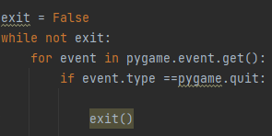

This commands is for exit the if it finished which while not exit the game will still running then if the event is false this means the is finished or you just quit the game.

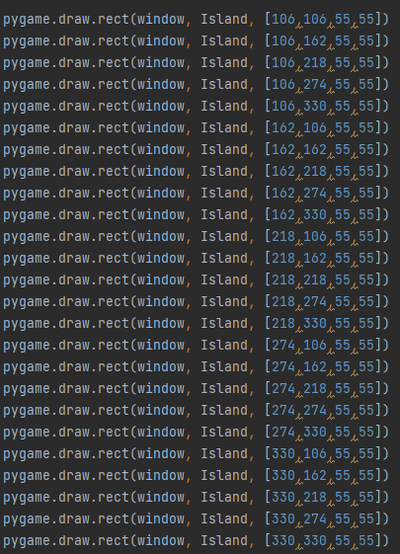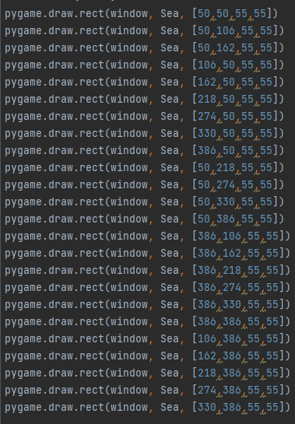

This bunch of blocks is for giving the Sea and Island the coordinates that suits the game and its contain 4 numbers, thew first one is for the thing we are drawing is in the left or right and we setting that by numbers, the second number is for knowing the drawing is in the top or the bottom and also setting that by numbers,  
then the last two numbers is for determining the height and width of the drawings and set them in the location we want and this is how we implement a game in pycharm using python programming language.